How to work with inbuilt ADC Module of PIC Microcontroller (PIC18F4550)
PIC010
- Summary
- Description
- Circuit Diagram
- Video
- Code
- Components

Summary
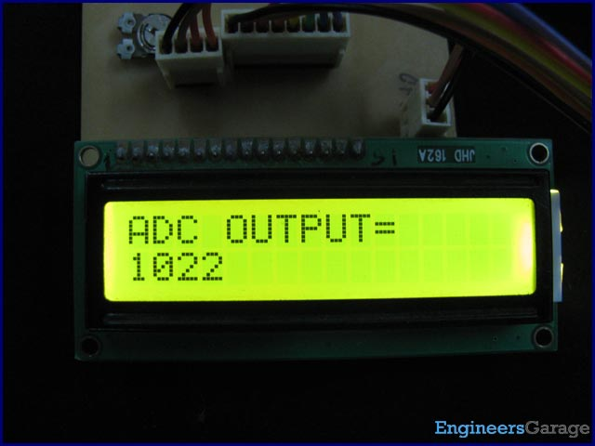
A microcontroller, a digital device, can read, execute and transmit only digital signals. On the contrary, the outputs of the most of the transducers are analog in nature. Thus it is hard to interface these transducers directly with controllers. Analog-to-digital convertor (ADC) ICs are one way to make the analog input compatible with the microcontroller.
Using an external ADC adds complexity to the circuit. To avoid this complexity, PIC Microcontrollers have in-built ADC module which reduces the cost and connections of the circuit. This article explains the in-built ADC of PIC18F4550 controller.

Description
As mentioned in the summary, a PIC microcontroller has inbuilt ADC for A/D conversion. The ADC module of PIC18F4550 controller has following specifications:
· 10-bit resolution output which means that an analog input gets converted into a corresponding 10-bit digital output.
· 13 channels which means that a total of 13 analog signals can be converted simultaneously into digital.
· Vref+ (RA3) and Vref- (RA2) pins for external reference voltage.
· 8 selectable clock options.
· ADC can be in auto-triggering mode for continuous A/D conversion.

ADC Registers:
To work with the inbuilt ADC of this PIC microcontroller, the certain registers are required to be configured. Each of these ADC registers has been explained below.

1. ADCON0 (A/D CONTROL REGISTER 0)

Bit 7 | Bit 6 | Bit 5 | Bit 4 | Bit 3 | Bit 2 | Bit 1 | Bit 0
— | — | CHS3 | CHS2 | CHS1 | CHS0 | GO/DONE | ADON

ADON: This bit is used to enable/disable the ADC peripheral of the PIC.
1 = A/D converter module is enabled
0 = A/D converter module is disabled
GO/DONE: This is A/D conversion status bit. For ADON=1,
1 = A/D conversion in progress
0 = A/D Idle
CHS3: CHS0: These bits are used to select a particular analog channel from 13 available channels (0-12) which are multiplexed with digital I/O pins. The following table shows the bit configuration to select these analog channels:

CHS3:CHS0 | Analog Channel | Pin
0000 | Channel 0 | RA0/AN0
0001 | Channel 1 | RA1/AN1
0010 | Channel 2 | RA2/AN2
0011 | Channel 3 | RA3/AN3
0100 | Channel 4 | RA5/AN4
0101 | Channel 5 | RE0/AN5
0110 | Channel 6 | RE1/AN6
0111 | Channel 7 | RE2/AN7
1000 | Channel 8 | RB2/AN8
1001 | Channel 9 | RB3/AN9
1010 | Channel 10 | RB1/AN10
1011 | Channel 11 | RB4/AN11
1100 | Channel 12 | RB0/AN12

2. ADCON1 (A/D CONTROL REGISTER 1)

Bit 7 | Bit 6 | Bit 5 | Bit 4 | Bit 3 | Bit 2 | Bit 1 | Bit 0
— | — | VCFG1 | VCFG0 | PCFG3 | PCFG2 | PCFG1 | PCFG0

PCFG0:PCFG3: As mentioned earlier, there are 13 analog channels in PIC18F4550 which are multiplexed with digital I/O pins. This means that such a (multiplexed) pin can act as either a digital I/O pin or an analog input pin. Either of these configurations is selected by these bits. The following table shows the bit configuration to make a pin D (Digital I/O) or A (Analog input):

PCFG3:  PCFG0 | AN12 | AN11 | AN10 | AN9 | AN8 | AN7 | AN6 | AN5 | AN4 | AN3 | AN2 | AN1 | AN0
0000 | A | A | A | A | A | A | A | A | A | A | A | A | A
0001 | A | A | A | A | A | A | A | A | A | A | A | A | A
0010 | A | A | A | A | A | A | A | A | A | A | A | A | A
0011 | D | A | A | A | A | A | A | A | A | A | A | A | A
0100 | D | D | A | A | A | A | A | A | A | A | A | A | A
0101 | D | D | D | A | A | A | A | A | A | A | A | A | A
0110 | D | D | D | D | A | A | A | A | A | A | A | A | A
0111 | D | D | D | D | D | A | A | A | A | A | A | A | A
1000 | D | D | D | D | D | D | A | A | A | A | A | A | A
1001 | D | D | D | D | D | D | D | A | A | A | A | A | A
1010 | D | D | D | D | D | D | D | D | A | A | A | A | A
1011 | D | D | D | D | D | D | D | D | D | A | A | A | A
1100 | D | D | D | D | D | D | D | D | D | D | A | A | A
1101 | D | D | D | D | D | D | D | D | D | D | D | A | A
1110 | D | D | D | D | D | D | D | D | D | D | D | D | A
1111 | D | D | D | D | D | D | D | D | D | D | D | D | D

VCGF1-VCGF0: These are voltage configuration bits to select the reference voltage (Vref) for ADC module.

Bit | = 1 | = 0
VCGF0 | Vref+ (RA3) | Vcc
VCGF1 | Vref- (RA2) | Vss (GND)

3. ADCON2 (A/D CONTROL REGISTER 2)

Bit 7 | Bit 6 | Bit 5 | Bit 4 | Bit 3 | Bit 2 | Bit 1 | Bit 0
ADFM | — | ACQT2 | ACQT1 | ACQT0 | ADCS2 | ADCS1 | ADCS0

ADCS2:ADCS0: These bits are used to select the clock option for ADC peripheral. The following table shows the bit configuration to select from different clock options:

ADCS2:ADCS0 | Clock Option
000 | FRC (clock derived from A/D RC oscillator)
001 | FOSC/64
010 | FOSC/16
011 | FOSC/4
100 | FRC (clock derived from A/D RC oscillator)
101 | FOSC/32
110 | FOSC/8
111 | FOSC/2

ACQT2:ACQT0: These bits are used to set the acquisition time of the ADC. The acquisition time is the time required to charge and discharge the holding capacitor of the ADC.
ADFM: This bit is used to select the format of digital output.
1 = Right justified (LSB to MSB)
0 = Left justified (MSB to LSB)

4. ADRESL & ADRESH:
Since the ADC module of PIC provides 10-bit digital output after A/D conversion, this output is stored in two 8-bit registers, namely, ADRESL & ADRESH. The lower byte is stored in ADRESL (A/D Result High register) while the higher byte is stored in ADRESH (A/D Result Low register).

Working with ADC
Objective: To select an analog channel of PIC18F4550’s in-built ADC and provide an analog input (0 to 5 volt) to it using a variable resistor or preset (20 k). (See circuit diagram) The main objective is to read the analog signal and display the corresponding digital value on LCD. (Also see interfacing LCD with PIC)

Programming Steps:
1. Set number of analog inputs by setting PCFG3:PCFG0 (ADCON1).
2. Select the analog channel by setting CHS3:CHS0 bits (ADCON0).
3. Select the clock option, acquisition time output format by configuring the ADCON2 register.
4. Enable the ADC by making ADON bit (ADCON0) high.
5. Start the conversion by setting GO/DONE bit (ADCON0).
6. Wait until GO/DONE bits becomes low. This indicates that the A/D conversion is over.
7. Store A/D conversion result from ADRESH:ADRESL into a variable.
8. Covert the resultant value to its corresponding ASCII value and display on LCD.

Circuit Diagram
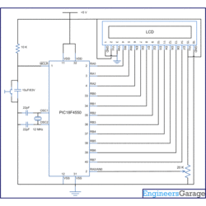

Video

Code
// Program to depict working with inbuilt ADC of PIC18F4550 Microcontroller
// This code uses Channel0 (zero) of PIC's ADC Module
// Configuration bits
/* _CPUDIV_OSC1_PLL2_1L, // Divide clock by 2
_FOSC_HS_1H, // Select High Speed (HS) oscillator
_WDT_OFF_2H, // Watchdog Timer off
MCLRE_ON_3H // Master Clear on
*/
#define rs LATA.F0
#define rw LATA.F1
#define en LATA.F2
#define lcdport LATB
void lcd_ini();
void lcdcmd(unsigned char);
void lcddata(unsigned char);
void adc_con(unsigned int);
void adc_init();
unsigned char data[20]="ADC OUTPUT=";
unsigned int digital_out[10],avg_output=0,temp;
unsigned int i=0;
void main()
{
TRISA=0x01; // Configure RA0 as input pin
LATA=0;
TRISB=0; // Configure Port B as output port
LATB=0;
TRISD=0;
LATD=0;
lcd_ini(); // LCD initialization
while(data[i]!='\0')
{
lcddata(data[i]); // Call lcddata function to send character one by from 'data' array
i++;
}
adc_init(); //ADC Initialization
while(1)
{
temp=0;
for(i=0;i<10;i++)
{
ADCON0|=(1<<GO); // Start A/D conversion
while(!(ADCON0 & (1<<GO))); // Wait until conversion gets over
digital_out[i]=((ADRESL)|(ADRESH<<8)); // Store 10-bit output into a 16-bit variable
Delay_ms(20);
temp=temp+digital_out[i];
}
avg_output=temp/10; // Take average of ten digital values for stablity
adc_con(avg_output); // Function to convert the decimal vaule to its corresponding ASCII
}
}
void adc_init()
{
ADCON1=0x0E; // Make RA0/AN0 pin as analog pin (Other pins remain to be digital I/O)
ADCON0=0x00; // Select Channel0 & ADC off
ADCON2=0x8A; // Left justified, 2TAD acquiciation time, Fosc/32 clock option
ADCON0.ADON=1; // Enable ADC
}
void lcd_ini()
{
lcdcmd(0x38); // Configure the LCD in 8-bit mode, 2 line and 5x7 font
lcdcmd(0x0C); // Display On and Cursor Off
lcdcmd(0x01); // Clear display screen
lcdcmd(0x06); // Increment cursor
lcdcmd(0x80); // Set cursor position to 1st line, 1st column
}
void adc_con(unsigned int adc_out)
{
unsigned int adc_out1;
int i=0;
char position=0xC3;
for(i=0;i<=3;i++)
{
adc_out1=adc_out%10; // To exract the unit position digit
adc_out=adc_out/10;
lcdcmd(position);
lcddata(48+adc_out1); // Convert into its corresponding ASCII
position--;
}
}
void lcdcmd(unsigned char cmdout)
{
lcdport=cmdout; //Send command to lcdport=PORTB
rs=0;
rw=0;
en=1;
Delay_ms(10);
en=0;
}
void lcddata(unsigned char dataout)
{
lcdport=dataout; //Send data to lcdport=PORTB
rs=1;
rw=0;
en=1;
Delay_ms(10);
en=0;
}

Components
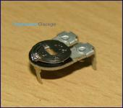  - 10,443-Reads | Preset  A preset is a three legged electronic component which can be made to offer varying resistance in a circuit. The resistance is varied by adjusting the rotary control over it. The adjustment can be done by using a small screw driver or...
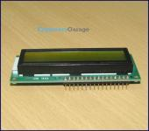  - 20,298-Reads | LCD  LCD (Liquid Crystal Display) screen is an electronic display module and find a wide range of applications. A 16x2 LCD display is very basic module and is very commonly used in various devices and circuits. These modules are preferred over seven segments...
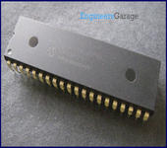  - 2,711-Reads | PIC18F4550  PIC18F4550 is an 8-bit microcontroller of PIC18 family. PIC18F family is based on 16-bit instruction set architecture. PIC18F4550 consists of 32 KB flash memory, 2 KB SRAM and 256 Bytes EEPROM.  ...
- 2369 reads

